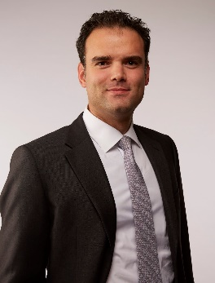**Full Name : Eren Cetinkaya**

Picture

**Email : eren_cetinkaya@mckinsey.com**

**Organization : McKinsey & Company**

**Current Position : Partner, Leader Petrochemicals**

**Title of Presentation : Embracing Uncertainty: Unleashing Value in the Evolving Industry Landscape**

**Presentation Abstract:**

A brief overview of current industry landscape covering

* Geopolitics and impact of recent events on select chemical industries
* Chinese capacity build out
* Sustainability

Strategic opportunities to deliver value in current market landscape, such as

* **AI in Chemicals-** Proven use cases deliver significant impact with low capex, e.g. furnace optimization in crackers, predictive maintenance, etc
* **Feedstock diversification and optimization-**Under Trump administration, additional supply of US crude oil and natural gas expected.
* **China + X-** Established Chinese players with access to technology seek regional manufacturing hubs and partners, e.g. battery components, EV parts
* **New low-carbon products and/or chemicals enabling the energy transition, e.g.,** 
  + Low-CO2e process innovation, e.g., chemical recycling, CO2 conversion, enzymatic and catalytic conversions
  + Performance materials, e.g., increased durability, thermal conductivity, absorption and refraction properties
  + Recyclability by design, e.g., debondable adhesives, (multi-layered) mono-material solutions, modular design
* **Green biz long-term growth-** New green biz (e.g. battery recycling, textile recycling) to grow but pace may be slower in mid-term