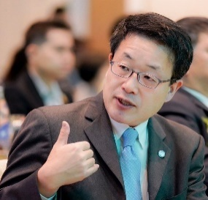

**Full Name : Fukuya IINO**

**Organization : United Nations Industrial Development Organization**

**(UNIDO) for Thailand, Malaysia, Cambodia, Vietnam, Laos and Myanmar based in Bangkok, Thailand**

**Current Position : UNIDO Representative**

**Title of Presentation : Decarbonization of the Cement and Concrete Sectors in Thailand**

**Presentation Abstract :**

The United Nations Industrial Development Organization (UNIDO with its headquarters located in Vienna, Austria) has the largest UN climate change mitigation project portfolio in Thailand on Thailand’s emission trade system, decarbonization of hard-to-abate industrial sectors including the cement and steel industries, energy efficiency policies, battery swapping for electric motorcycles, and European Union’s carbon border adjustment mechanism (CBAM), while promoting clean new energy such as prioritized applications of green hydrogen. The decarbonization of the concrete and cement sector needs to be addressed in a multi-faucet manner. Cement and concrete represent over 15% of global CO2 emissions. In the case of cement, over half of emissions arise from the calcination process meaning that renewable energy alone is insufficient to achieve zero-carbon cement. The processing of feedstock generates about 45% of CO2 emissions in these sectors. The emissions can be reduced by changing feedstocks or processes rather than changing to low-carbon energy sources. Research and development of low-carbon and alternative cement formulations could significantly reduce CO2 emissions. Green public procurement, particularly in government construction projects, would be an avenue for creating demand for low-carbon products. The use of supplementary cementitious materials (SCMs) and alternative raw materials can be explored. Waste to energy has the potential to reduce CO2 emission by replacing fossil fuel generated high-temperature heat demand for production. Carbon capture, utilization and storage (CCUS) is also to be studied.